



Chameleon 2.0 Users Guide

Revision 0.4

Table of Contents

Introduction Page 2  
Running the Installer Page 3  
Custom Install Page 4  
Advanced Options Page 6  
Boot.plist configuration Page 7  
Custom boot.plist variables Page 6  
Themes Page 8  
Screen Layout Page 9  
Boot devices Page 8  
Boot prompt Page 9  
Info box Page 10  
Menu Page 11  
Boot display Page 12

Introduction

Chameleon 2.0 the latest version of the of the Chameleon boot loader for OS X on X86 hardware. It is an EFI boot loader that is designed to replace the Darwin and PC_EFI boot loaders. It has several new features including:

* Graphical User Interface mode
* Customizable Images
* Support for GPT/MBR partition types
* RAID support

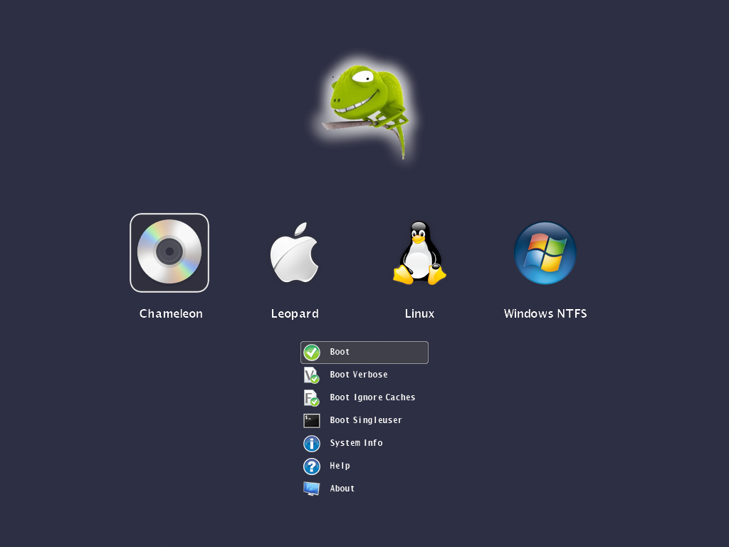

Chameleon can be installed on any BIOS bootable device such as USB flash drives,   
hard drives, and of course off a cd-rom.

Installing Chameleon

Chameleon 2.0 includes it’s own installer package which will install the required boot loader components as well as the new themes onto a hard drive or other bootable device. Once the install is complete you will need to reboot your computer to use the new boot loader features

To get started, double click on the Chameleon Installer.

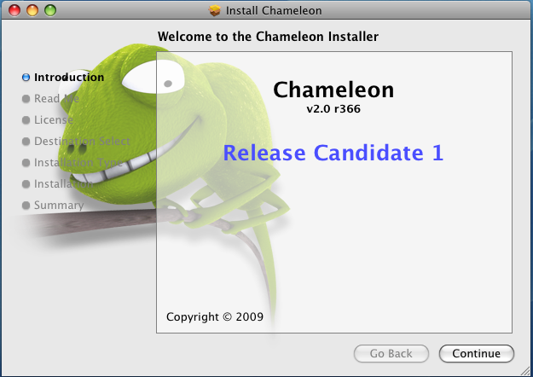

Click “Continue” and you will be given the option of selecting, “Install” using the default settings, “Customize” to pick addition options or “Change Install Location” to pick a different volume to install to.

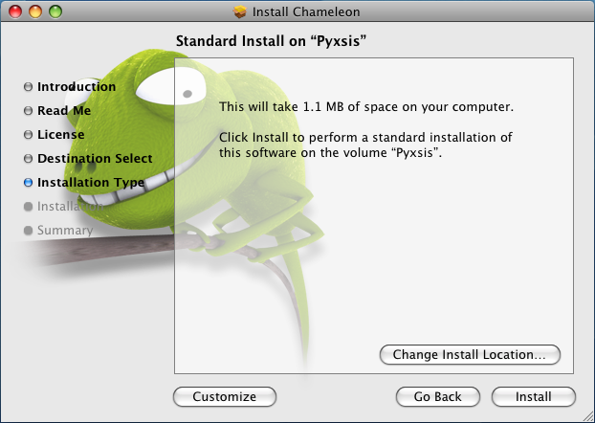

Custom Install

If you select Customize you have the option of selecting different themes or variables to be passed at boot time to the kernel

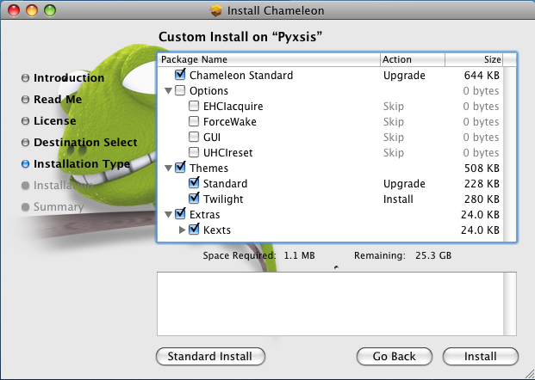

Options

EHCIacquire Can fix some rare USB issues on boot.  
 ForceWake Cleans the hibernate image on resume  
 GUI GUI bootloader on or of  
 UHCIreset Reset USB for some rare USB issues on boot

Themes  
 Default theme and Twilight are offered as for you to use

Extras  
 Kexts for AHCI and Intel PIIXATA will get installed into /Extra

Finishing Chameleon install

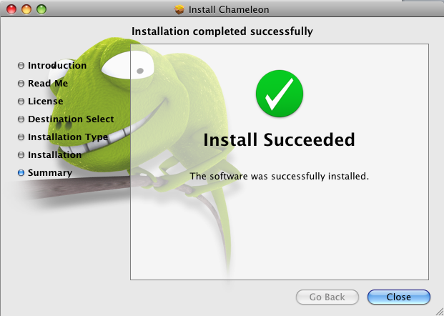

If you see this screen, you’re done with the install and everything has installed. All you need to do now is reboot and watch your computer load the new Chameleon and enjoy the extra features that it has over the previous versions!

Booting

Chameleon is setup to automatically boot your operating system with the default settings but has the ability to pass variables to the kernel. You can pass startup options to the kernel by pressing any key when you see the boot logo and the type them to be sent to the operating system after you hit enter.

Advanced Options

Advanced startup options use the following syntax:

[device]<kernel> [arguments]

Example arguments include

device: rd= device name> rd=*<IODeviceTree path>

(Device name sample rd=/dev/disk0s2)  
(Device tree sample rd=*/PCI0@0/CHN0@0/@0:1)

Kernel: Sometimes you need to use a different kernel for testing, or you need to use the old one after an install that didn’t work the way you wanted it too =)

kernel: kernel name

Example: mach_kernel.voodoo

Flags allow you pass arguments without having to make them a permanent config settings. Examples of valid flags are:

-f This forces rebuilding of extensions cache  
-s Boots into a single user command line mode  
-v Verbose, boots in text mode showing all debug info and errors  
-x Boots into safe mode

"Graphics Mode"="1024x768x32" : Tells VESA to boot with this resolution, the x32 is bit depth and is only compatible with VESA 3.0 and up

rd=disk0s1: Tells Darwin to boot from a certain partition specified in BSD format. Disk 0 specifies first HDD and s1 specifies first partition as 0 is the MBR.

cpus=1: Tells the system how many CPUs or cores to use, useful for Core Duo users.

platform=X86PC: Can be used if problems with normal booting,

platform=ACPI: another option if normal booting fails

-legacy - Boots OS X in 32bit mode rather than 64bit if 64bit is used due to a 64bit processor

idehalt=0 - May stop stuttering

kernel debug flags

(e.g. debug=0x144) io=0xffffffff defined in IOKit/IOKitDebug.h)

Example: mach_kernel rd=disk0s1 -v "Graphics Mode"="1024x768x32@85"

If the computer won't start up properly, you may be able to start it up using safe mode.   
Use the startup command “-x” to start up in safe mode, which ignores all cached driver files.

Example: -x -v

Special booter commands:

?memory Displays information about the computer's memory  
 ?video Displays VESA video modes supported by the computer's BIOS.  
 ?norescan Leaves CD-ROM rescan mode.

Additional useful command-line options:

config=<file> Use an alternate Boot.plist file.

Boot.plist

Options useful in the org.chameleon.Boot.plist file:

"Boot Graphics"=Yes|No Use graphics mode or text mode when starting.  
"Quiet Boot"=Yes|No Use quiet boot mode (no messages or prompt).  
Timeout=8 Number of seconds to pause at the boot: prompt.  
"Instant Menu"=Yes Force displaying the partition selection menu.   
GUI=No Disable the GUI (enabled by default).  
USBBusFix=Yes Enable the EHCI and UHCI fixes (disabled by default). EHCIacquire=Yes Enable the EHCI fix (disabled by default).  
UHCIreset=Yes Enable the UHCI fix (disabled by default).  
Wake=No Disable wake up after hibernation (enabled by default). ForceWake=Yes Force using the sleepimage (disabled by default). WakeImage=<file> Use an alternate sleepimage file (default path is   
 /private/var/vm/sleepimage).  
DropSSDT=Yes Skip the SSDT tables while relocating the ACPI tables.  
DSDT=<file> Use an alternate DSDT.aml file (default paths are /DSDT.aml   
 or /Extra/DSDT.aml).  
Rescan=Yes Enable CD-ROM rescan mode.  
"Rescan Prompt"=Yes Prompts for enable CD-ROM rescan mode.

Themes

Chameleon 2 lets you create or customize the boot loader themes! You can edit the file in /Extra/Themes/Default/theme.plist. The following variables are changeable in the theme.plist to customize your theme.

Images and Color

Chameleon 2 has user replaceable images, and colors that you can customize. The images are saved in the /Extra/Themes/Default folder. All images must be in .png format .

You can change the color of all the text and other widgets by using RGB color codes. Below is a basic color code chart but the full RGB color pallet is supported.

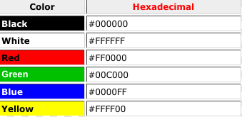

Screen

Set the display dimensions to use when in the graphic user interface, will attempt to find the closest one available.

screen_width

<key>screen_width</key>  
<string>1024</string> 1024 pixels wide screen

screen_height

<key>screen_height</key>  
 <string>768</string> 768 pixels high screen

screen_bgcolor

<key>screen_bgcolor</key>  
<string>#222334</string> web format #RRGGBB

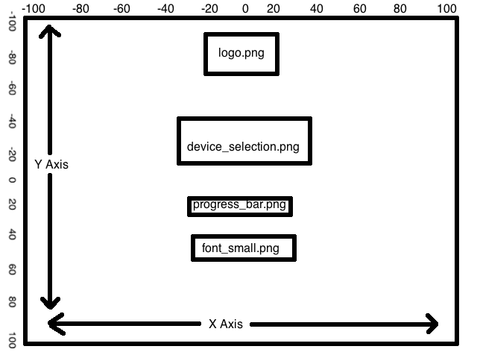

The Chameleon screen layout

Background

Set the position of background.png within the screen

background_pos_x

<key>background_pos_x</key>  
<string>-0</string> 0 pixels from reverse origin along the x axis

background_pos_y

<key>background_pos_y</key>  
<string>-0</string> 0 pixels from reverse origin along the y axis

Logo

Set the position of logo.png within the screen

logo_pos_x

<key>logo_pos_x</key>  
<string>0</string> 0 pixels from origin along the x axis

logo_pos_y

<key>logo_pos_y</key>  
<string>0</string> 0 pixels from origin along the y axis

Devices

Set the position of the device list within the screen

devices_pos_x

<key>devices_pos_x</key>  
<string></string> blank to center on the x axis

devices_pos_y

<key>logo_pos_y</key>

<string></string> blank to center on the y axis

devices_max_visible

<key>devices_max_visible</key> maximum number of devices visible

<string>4</string>

devices_icon_spacing

<key>devices_icon_spacing</key> spaces between the drive icons

<string>20</string>

devices_layout

<key>devices_layout</key>

<string>horizontal</string> horizontal or vertical list

devices_bgcolor

<key>devices_bgcolor</key>

<string>#000000</string> web format #RRGGBB

devices_transparency

<key>devices_transparency</key>

<string>128</string> 0 (Opaque) -> 255 (Transparent)

Boot prompt

Set the position of the boot prompt within the screen

bootprompt_pos_x

<key>bootprompt_pos_x</key>

<string></string> blank to center on the x axis

bootprompt_pos_y

<key>bootprompt_pos_y</key>

<string></string> blank to center on the y axis

bootprompt_width

<key>bootprompt_width</key>

<string>-20</string> 20 pixels less than the screen's width window

bootprompt_height

<key>bootprompt_height</key>

<string>20</string> 20 pixel high window

bootprompt_textmargin_h

<key>bootprompt_textmargin_h</key> 8 pixel horizontal text margin left and right

<string>8</string>

bootprompt_textmargin_v

<key>bootprompt_textmargin_v</key> 4 px vertical text margin both top and bottom

<string>4</string>

bootprompt_bgcolor

<key>bootprompt_bgcolor</key>

<string>0x333445</string> web format #RRGGBB

bootprompt_transparency

<key>bootprompt_transparency</key>

<string>0</string> 0 (Opaque) -> 255 (Transparent)

Info box

Set the position of the info box within the screen

infobox_pos_x

<key>infobox_pos_x</key>

<string></string> blank to center on the x axis

infobox_pos_y

<key>infobox_pos_y</key>

<string></string> blank center on the y axis

infobox_width

<key>infobox_width</key>

<string>550</string> 550 pixels wide

infobox_height

<key>infobox_height</key>

<string>406</string> 406 pixels high

infobox_bgcolor

<key>infobox_bgcolor</key>

<string>#333445</string> web format #RRGGBB

infobox_transparency

<key>infobox_transparency</key>

<string>64</string> 0 (Opaque) -> 255 (Transparent)

Menu

Set the position of the pop up menu within the screen

menu_pos_x

<key>menu_pos_x</key>

<string></string> center on the x axis

menu_pos_y

<key>menu_pos_y</key>

<string></string> center on the y axis

menu_bgcolor

<key>menu_bgcolor</key>

<string>#111223</string> web format #RRGGBB

menu_transparency

<key>menu_transparency</key>

<string>0</string> 0 (Opaque) -> 255 (Transparent)

Boot Display

Set the display dimensions to use when booting the kernel, will attempt to find the closest one available.

boot_width

<key>boot_width</key>

<string>1280</string> 1280 pixels wide screen

boot_height

<key>boot_height</key>

<string>1024</string> 1024 pixels tall screen

Getting in touch

Chameleon homepage: [**http://chameleon.osx86.hu/**](http://chameleon.osx86.hu/)

E-mail : http://chameleon.osx86.hu/contact

*Hope you guys like the bootloader! We appreciate your feedback and support*